Tammy 12/5/2019

Observations and Playtester Comments

# In-Game Observations

[Your thoughts as you watch the testers play]

* Need more interaction and be able to know that you can go inside houses

# In-Game Questions

Why did you make that choice? (why did you decide to go into the house)

* My friend told me to

Does that rule seem confusing?

What did you think that would do?(when went inside the house)

* It would open up a new view

What is confusing for you?

* What is the objective of the game?

# Postgame Questions

[Questions you ask the testers as they have played]

Why did you go into this house versus the other one first?

* Just went into the first house I saw

## General Questions

What was your ﬁrst impression?

* She liked the visuals, the 2d aspect

How did that impression change as you played?

* She still liked everything; it looks like pokemon

Was there anything you found frustrating?

* Couldn’t win the game

Did the game drag at any point?

* She was just roaming

Were there particular aspects that you found satisfying?

* Moving around

What was the most exciting moment in the game?

* When the bunny pushed me back

Did the game feel too long, too short, or just about right?

* Reasonable once implemented

## Formal Elements

Describe the objective of the game.

* Just explore the world and finish the story

Was the objective clear at all times?

* No, there is no back story yet

What types of choices did you make during the game?

* Left, right, up, down, whether to go into a house or not, whether I should approach the other agents

What was the most important decision you made?

* Stepping in the house

What was your strategy for winning?

* NA

Did you ﬁnd any loopholes in the system?

* You can’t talk to the people yet

How would you describe the conﬂict?

* NA

In what way did you interact with other players?

* NA

Do you prefer to play alone or with human opponents?

* alone

What elements do you think could be improved?

* The storyline, and backstory

## Dramatic Elements

Was the game’s premise appealing to you?

* yea

Did the story enhance or detract from the game?

* It will enhance, cause there is no story yet

As you played, did the story evolve with the game?

* NA

Is this game appropriate for the target audience?

* yea

On a piece of paper, graph your emotional involvement over the course of the game.

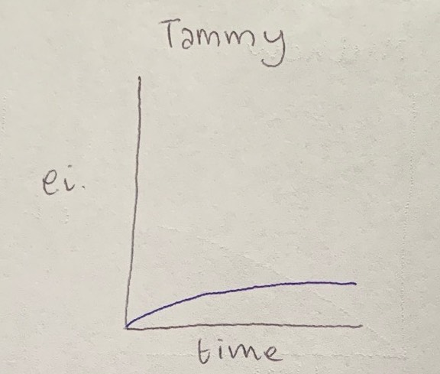

Did you feel a sense of dramatic climax as the game progressed?

* NA

How would you make the story and game work better as a whole?

* Add a story

## Procedures, rules, interface, and controls

Were the procedures and rules easy to understand?

* Yea, just move around

How did the controls feel? Did they make sense?

* Yea, the character was easy to move around

Could you ﬁnd the information you needed on the interface?

* Generally, yea

Was there anything about the interface you would change?

* no

Did anything feel clunky, awkward, or confusing?

* no

Are there any controls or interface features you would like to see added?

* “press a to interact”

## End of Session

Overall, how would you describe this game’s appeal?

* She was very excited in the beginning cause it was a cute game and wanted to be able to explore the game.

Would you purchase this game?

* Yes, for like $1

What elements of the game have reacted you?

* The bunny

What was missing from the game?

* The storyline

If you could change just one thing, what would it be?

* More interaction

Who do you think is the target audience for this game?

* tweens

If you were to give this game as a gift, who would you give it to?

* My younger brother

# Revision Ideas

[Ideas you have for improving the game]

* Add arrow on map to be able to go into house as indicator
* Make sure to add more interactions and popups
* Script needs to be finished soon